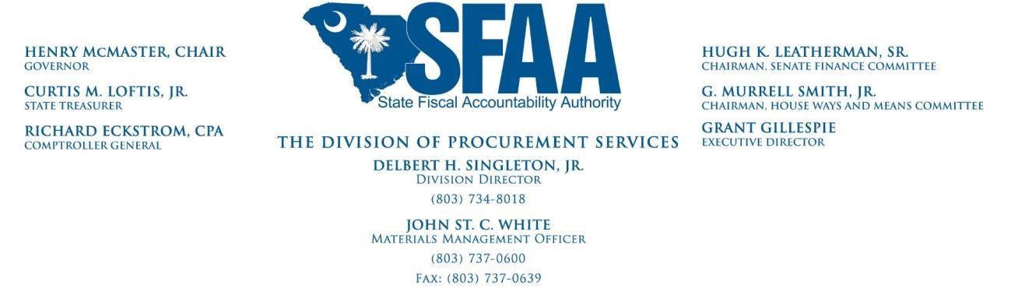
5/16/2019

MEMORANDUM

To: Agency Directors, Finance Directors, Procurement Directors, and their Staff

From: John St. C. White, PE,
Materials Management Officer

Re: S. 530, Ratification #52, General Bill Amending the Consolidated Procurement Code

On May 13, 2019, the Governor signed S. 530. The changes made by S. 530 apply to all solicitations issued after May 13, 2019.

A limited number of provisions contained in S. 530 depend on the publication of regulations and until those regulations are adopted, those provisions cannot be used. The Act directs the State Fiscal Accountability Authority (SFAA) to publish interim regulations no later than September, 2019, and to publish a draft of the proposed final regulations no later than November, 2019. We are developing a schedule for drafting both with an eye to allowing agencies as much time as possible to review and comment on these regulations. Currently, we anticipate providing initial drafts of the proposed regulations for comment on June 4, 2019. We anticipate a meeting with Agencies on the afternoon of June 11, 2019, to explain the initial drafts (venue to be announced). Finally, we anticipate a deadline of June 18, 2019, for comments on the initial drafts. Thereafter, we will modify the initial drafts taking into consideration the comments received and provide another (albeit shorter) opportunity for comments after these revisions.

We are also working on training sessions to address the changes made to the Consolidated Procurement Code by S. 530. We anticipate a series of one-hour online training sessions to deliver the training. These sessions will be recorded and made available to those who are not able to participate via the internet.

Provisions Requiring Regulations to Implement

• Section 11-35-410(C) – Public availability and disposition of documents submitted in response to a solicitation where no award is made

Section 11-35-1535 – Competitive Negotiations
1201 MAIN STREET, SUITE 600 ♦ COLUMBIA, SOUTH CAROLINA 29201 HTTP://PROCUREMENT.SC.GOV

New Provisions Taking Effect Immediately but to be used Cautiously
Commercially Available Off the Shelf Products – Sections 11-35-1410(1) & (2), -1550(2)(b), and -2040. While these provisions take effect immediately, the provisions regarding commercially available off-the-shelf-products are entirely new to the State and warrant regulations providing guidance on their use. Therefore, we strongly urge agencies to wait until interim regulations are adopted before using these provisions thus avoiding potential audit exceptions.

Key Provisions Taking Effect Immediately

- Posting Notice of Intent to Award and Protests, Sections 11-35-410(F), 1520(1),
11-35-4210 o Notice of Intent must be posted for seven business days o An actual bidder or offeror may file a notice of intent to protest within seven business days after posting
  - If bidder/offeror appropriately files notice of intent to protest, may perfect protest within fifteen days after posting the Notice of Intent
  - Make procurement documents available within five days of receipt of FOIA request from actual bidder/offer during protest period
- Notice of revised award posting date given by posting for three business days and sending to all bidders, Section 11-35-1520(10)
- Discussions with bidders o repealed in:

▪ Section 11-35-1520(8) Competitive Sealed Bidding
▪ Section 11-35-1525(6) Competitive Fixed Price Bidding o replaced with clarifications in Section 11-35-1528(6) Best Value Bidding
- Small Purchase Procedures in Section 11-35-1550 (See caveat for commercially available off-the-shelf products above)
- Advertising sole source procurements with a potential value of $50,000 or more in SCBO in advance of procurement – Section 11-35-1560
- Advertising emergency procurements with a value greater than $50,000 in SCBO as soon as practicable – Section 11-35-1570
- Architect Engineer small procurement limits – Section 11-35-3230
- Construction Task Orders – Section 11-35-3320 (OSE is working on guidance which will be forthcoming shortly)

We are excited about these changes and look forward to working with all procurement professionals to implement them.

cc: Grant Gillespie, Executive Director Delbert Singleton, Division Director

