SAP
SAP
STATE OF SOUTH CAROLINA
SAP
SFAA, DIV. OF PROCUREMENT SERVICES, MMO
1201 MAIN STREET, SUITE 600
COLUMBIA SC 29201
SAP

Statement of Award
Emergency Procurement
SAP
Posting Date: September 10, 2020
SAP

SAP
Online platform to process applications and process grants to eligible independent K-12 schools on behalf of students in kindergarten through 12 whose family income is 300 percent or less of the federal poverty level.

SAP
SAP
P
SAP
AWARDED TO: Kleo, Inc. DBA Classwallet
6100 Hollywood Blvd Suite 108
Hollywood, Florida 33024

USING GOVERNMENTAL UNIT: South Carolina Office of the Governor

Any actual or prospective bidder, offeror, contractor, or subcontractor who is aggrieved in connection with the intended award or award of a contract pursuant to Section 11-35-1570 shall notify the appropriate chief procurement officer in writing of its intent to protest within five business days of the date that award or notification of intent to award, whichever is earlier, is posted in accordance with this code. Any actual or prospective bidder, offeror, contractor, or subcontractor who is aggrieved in connection with the intended award or award of such contract and has timely notified the appropriate chief procurement officer of its intent to protest, may protest to the appropriate chief procurement officer within fifteen days of the date award or notification of intent to award, whichever is earlier, is posted; except that a matter that could have been raised as a protest of a solicitation may not be raised as a protest of the award or intended award of a contract. A protest must be in writing, shall set forth the grounds of the protest and the relief requested with enough particularity to give notice of the issues to be decided, and must be received by the appropriate Chief Procurement Officer within the time provided. [Section 11-35- 4210]
SAP

PROTEST - CPO ADDRESS - MMO: Any protest must be addressed to the Chief Procurement Officer, Materials Management Office, and submitted in writing
(a) by email to protest-mmo@mmo.sc.gov,
(b) by post or delivery to 1201 Main Street, Suite 600, Columbia, SC 29201.

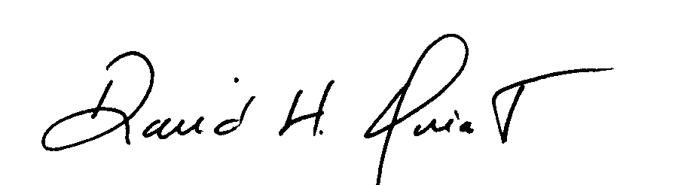
Procurement Officer
David Quiat

